**Privacy Policy**  
**Weave Recruitment Pty Ltd (ACN 683 967 302)**  
**Effective Date: 04/2025**

Weave Recruitment ("Weave Recruitment," "we," "our," or "us") is committed to protecting your privacy. This Privacy Policy explains how we collect, use, disclose, and protect your personal information in compliance with the Privacy Act 1988 (Cth) and the Australian Privacy Principles (APPs).

**1. Collection of Personal Information**

We may collect personal information from job seekers, employers, and other users of our services, including but not limited to:

* Name, contact details (phone number, email, address)
* Resume, employment history, and educational background
* Skills, qualifications, and references
* Salary expectations and job preferences
* Any other information relevant to recruitment services

We collect this information through our website, job applications, interviews, phone calls, emails, and other interactions with you.

**2. Use of Personal Information**

We use your personal information for the following purposes:

* Providing recruitment and placement services
* Assessing your suitability for job opportunities
* Communicating with you about job vacancies, career advice, and industry news
* Verifying your work history, qualifications, and references
* Complying with legal and regulatory requirements
* Improving our services and website functionality

**3. Disclosure of Personal Information**

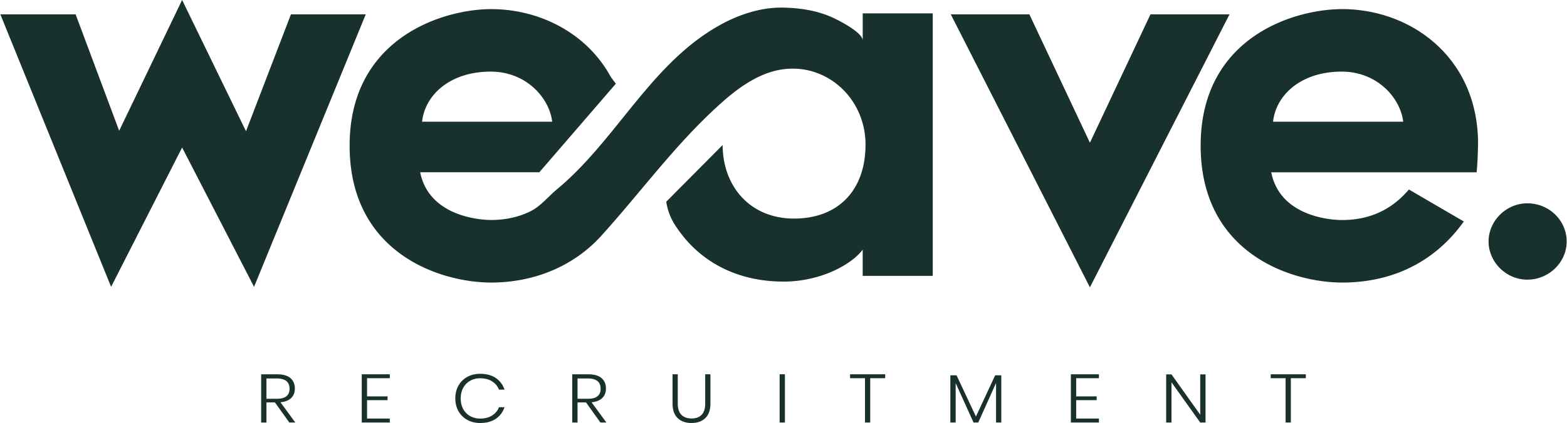We may disclose your personal information to:

* Prospective employers and clients seeking recruitment services
* Third-party service providers who assist in our operations (e.g., background checks, payroll processing, IT services)
* Legal or regulatory authorities where required by law
* Any other party with your consent

We take reasonable steps to ensure that third parties handle your information securely and in accordance with this Privacy Policy.

**4. Security of Personal Information**

We implement appropriate security measures to protect your personal information from misuse, loss, unauthorized access, modification, or disclosure. However, no data transmission over the internet can be guaranteed as completely secure.

**5. Access and Correction of Personal Information**

You have the right to access and correct your personal information. If you believe any information, we hold is incorrect or outdated, please contact us, and we will take reasonable steps to update or correct it. You may also request the deletion of your personal information, subject to legal and regulatory obligations requiring us to retain certain data.

**6. Retention of Personal Information**

We retain your personal information only for as long as necessary to fulfill the purposes outlined in this Privacy Policy or as required by law.

**7. Cookies and Website Tracking**

Our website may use cookies and similar technologies to improve user experience and analyse website traffic. You can manage your cookie preferences through your browser settings.

**8. Changes to This Privacy Policy**

We may update this Privacy Policy from time to time. Any changes will be posted on our website, and we encourage you to review it periodically.

**9. Contact Us**

If you have any questions, concerns, or requests regarding this Privacy Policy, please contact us at:

**Weave Recruitment (ACN 683 967 302)**  
17/570 Bourke Street, Melbourne, VIC, 3000  
admin@weaverecruitment.com.au

